IT3041 · INFORMATION RETRIEVAL AND WEB ANALYTICS

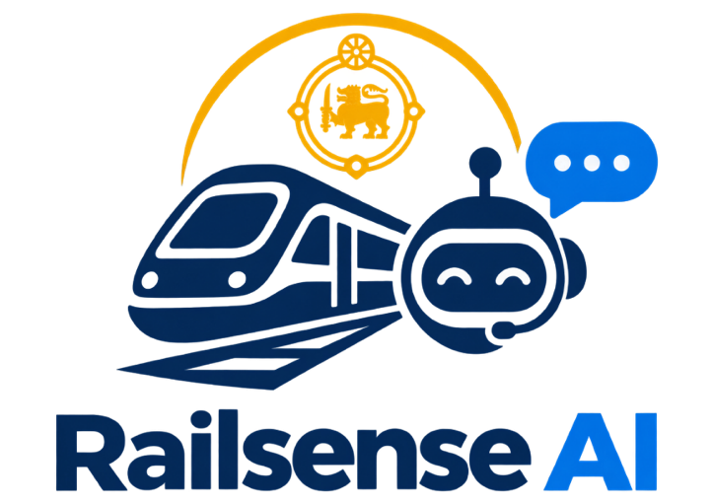
A Multi-Agent Agentic AI Platform for Sri Lanka Railways

Final Report
Design and Implementation of an Agentic AI System Integrating LLMs
, NLP, Security, and Information Retrieval
Domain: Railway · Four cooperating agents · One secure Communication Hub

Team member | Student ID | Module owned
S M T K Samarathunga | IT23716582 | M1 – Passenger Assistant
A K P C N Alawatta (Team leader) | IT23603004 | M2 – Operations and Delay Prediction
S A N D Aberathna | IT23600720 | M3 – Communication Hub, Booking and Security
Dilranga M.M.P.M | IT23858398 | M4 – Maintenance and Asset Intelligence

Group Name: Code4ce
Lecturer in charge: Mr. Samadhi Chathuranga Rathnayake
Institution: Sri Lanka Institute of Information Technology (SLIIT)
Submission: Final report, September 2026
Code repository: https://github.com/pasindi15/RailSence-AI
Abstract
Railway passengers and staff in Sri Lanka lack a single, trustworthy, real-time source of information about timetables, delays, bookings, incidents and equipment condition. RailSense AI addresses this with four cooperating, independently running agents – a multilingual Passenger Assistant (M1), an Operations and Delay-Prediction agent (M2), a Communication Hub with Booking and Security and Fraud agents (M3), and a Maintenance and Asset Intelligence agent (M4) – that exchange signed JSON messages through one central Hub.
The system integrates every technology the assignment asks for. Large language models (OpenRouter, Google Gemini and Groq-hosted Qwen) compose answers that are always grounded in retrieved evidence and checked by number and identifier guards. NLP provides language detection for Sinhala, Tamil and English, intent classification, named-entity recognition, incident classification and summarisation, and technician-note extraction. Information retrieval and retrieval-augmented generation run over ChromaDB and Supabase pgvector. Security spans JWT-signed inter-agent messages, an interaction allowlist, role-based access control, input sanitisation, rate limiting, circuit breakers, HMAC-hashed national identity numbers and append-only audit logs.
Measured results include a delay model with MAE 2.254 minutes and R² 0.894 on 780 held-out records, incident retrieval with P@3 of 1.0 over 150 queries, a fraud model with 99.17% accuracy and 100% recall, and an asset-health model with average R² 0.915. The report also presents the Responsible AI measures, a three-tier commercialisation plan with pricing, and deployment options for railway authorities.
Keywords: agentic AI, multi-agent systems, retrieval-augmented generation, delay prediction, fraud detection, predictive maintenance, Responsible AI, Sri Lanka Railways.
Table of Contents
1. Introduction 5
1.1 Background and problem statement 5
1.2 Objectives 5
1.3 Summary of contributions 5
1.4 How the assignment requirements are met 6
2. Domain and Users 7
2.1 Why the railway domain 7
2.2 Users and the value they receive 7
3. System Design 8
3.1 Architecture overview 8
3.2 Services and ports 8
3.3 Unified gateway 9
3.4 Data layer 9
3.5 The four agents 10
3.5.1 M1 – Passenger Assistant (Thisarani Kawya) 10
3.5.2 M2 – Operations and Delay Prediction (Pasindi Alawatta, team leader) 10
3.5.3 M3 – Communication Hub, Booking and Security (Navoda Dasun) 11
3.5.4 M4 – Maintenance and Asset Intelligence (Primesh Marasingha) 11
3.6 End-to-end scenarios 11
Scenario A – “Is the train delayed?” 11
Scenario B – Booking a ticket with fraud screening 12
Scenario C – Maintenance flag blocks bookings 12
Scenario D – Incident report to the public map 12
4. Agent Communication Protocol 13
4.1 Protocol choice 13
4.2 Message envelope 13
4.3 Intents and the interaction allowlist 13
4.4 The Hub pipeline 14
4.5 Registration and delegation 15
4.6 Event notifications 15
4.7 Example message 15
5. Methodology 16
5.1 Large language models 16
5.2 Prompt design and grounding 16
5.3 Natural language processing 17
5.4 Information retrieval and RAG 17
5.5 Machine learning 17
5.5.1 Delay prediction (M2) 17
5.5.2 Fraud screening (Security and Fraud agent) 18
5.5.3 Asset health (M4) 18
5.6 Datasets 18
5.7 Explainability by design 18
6. Security Implementation 19
6.1 Authentication and role-based access control 19
6.2 Securing agent-to-agent traffic 19
6.3 Input sanitisation and abuse prevention 20
6.4 Data protection 20
6.5 Audit and accountability 20
7. Responsible AI 21
7.1 Fairness and inclusion 21
7.2 Explainability 21
7.3 Transparency 22
7.4 Human oversight 22
7.5 Data protection and privacy 22
7.6 Dataset disclosure 22
8. Evaluation 23
8.1 Approach 23
8.2 Results summary 23
8.3 Delay prediction (M2) 23
8.4 NLP and retrieval 24
8.5 Fraud screening 24
8.6 Asset health 24
8.7 Software testing 24
8.8 Discussion 25
9. Commercialisation Plan 26
9.1 Value proposition 26
9.2 Target users and market 26
9.3 Product tiers and pricing 26
9.4 Cost structure 27
9.5 Deployment options 27
9.6 Go-to-market 28
9.7 Revenue model and sustainability 28
10. User Interface and Product Showcase 29
11. Team Contributions 31
12. Conclusion and Future Work 32
12.1 Conclusion 32
12.2 Future work 32
References 33
Appendix A. Running the Platform 34
Configuration keys 34
Appendix B. Reproducing the Evaluation 35
Appendix C. Service Interfaces 36

1. Introduction

1.1 Background and problem statement
Sri Lanka Railways carries large numbers of passengers every day across a network where delays, incidents and equipment failures directly affect people’s journeys. Four connected problems stand out:
- Passengers have no live, conversational way to ask whether their train is running late and why, in the language they are most comfortable with (Sinhala, Tamil or English).
- Operations staff must read and classify free-text incident reports by hand and have no early, explainable warning of delays.
- Booking and security staff must review ticketing behaviour manually, so unusual booking patterns are hard to spot quickly.
- Maintenance engineers often learn of asset problems only after they have caused a delay, and must search long manuals for the right procedure.
These problems belong to different user groups but depend on the same underlying facts – which trains exist, where they are, and whether they are fit to run. A single chatbot cannot serve all of them; a set of specialised agents that share one trusted registry and one communication channel can.

1.2 Objectives
- Design and build a multi-agent system with at least two interacting intelligent agents – delivered here as four agents plus a central Hub.
- Integrate LLMs, NLP, information retrieval, security features and a defined agent communication protocol, each with real depth.
- Ground every generated answer in retrieved or computed evidence, and make predictions explainable.
- Embed fairness, explainability, transparency and data protection throughout design, implementation and evaluation.
- Produce measurable evaluation evidence and a commercially credible deployment and pricing plan.

1.3 Summary of contributions
- Four specialised agents running as separate FastAPI services, each with its own models, data and prompts, behind two gateway portals (passenger side and officer side).
- A secure communication Hub that validates, authenticates, authorises, de-duplicates, rate-limits, routes and audits every inter-agent message.
- Grounded language model use: every LLM path has retrieval or tool evidence, a guard that rejects unsupported numbers and identifiers, and a deterministic fallback.
- End-to-end railway workflows: multilingual passenger chat, live train tracking with delay prediction, incident reporting with human verification and a public map, deterministic booking with QR tickets and fraud screening, and predictive maintenance with manual retrieval.
- Role-based administration: an Operations Control Room and Admin Console with officer management, model retraining and rollback, and audit exploration.
- Measured results for every model and retrieval component, plus automated test suites.

1.4 How the assignment requirements are met
Table 1. Assignment requirements and where the report addresses them.
Requirement (assignment brief) | How RailSense AI meets it | Sections
Solve a real problem in a selected domain | Railway operations for Sri Lanka Railways: passenger information, delay prediction, booking and fraud screening, incident handling and maintenance. | 1, 2
At least two interacting agents | Four agents (M1–M4) plus the Hub; requests, responses and event notifications flow between them. | 3, 4
One or more LLMs | OpenRouter (M1), Google Gemini (M2, M3, Security), Groq/Qwen (M4), all grounded and guarded. | 5.1, 5.2
NLP techniques (NER, summarisation) | Language detection, intent classification, NER, incident classification and summarisation, technician-note extraction, NIC normalisation. | 5.3
Information retrieval module | ChromaDB FAQ retrieval, Supabase pgvector incident, policy and manual retrieval, TF-IDF fallbacks, live-record retrieval. | 5.4
Security features | JWT, RBAC, sanitisation, rate limiting, circuit breakers, HMAC-hashed NICs, audit logs. | 6
Defined agent communication protocol | HTTP/JSON with a versioned, JWT-signed AgentMessage envelope routed through the Hub. | 4
Fairness, explainability, transparency, data protection | Trilingual support, feature importance and confidence labels, cited sources and technique badges, human review, masked and hashed identifiers. | 7
Commercialisation strategy with pricing | Three tiers, indicative pricing, cost drivers, deployment options and go-to-market plan. | 9
Evaluation results | Metrics for the delay, fraud and health models, NLP components and retrieval, plus test suites. | 8

2. Domain and Users

2.1 Why the railway domain
Railways are a natural fit for agentic AI. Operations produce structured history (routes, times, weather, incidents) suitable for prediction; passengers and staff communicate in free text and in three languages; ticketing generates behavioural patterns that reveal misuse; and equipment produces sensor readings and technician notes. Each of these needs a different kind of intelligence, yet they influence one another: maintenance flag changes which trains can be booked, an incident changes the delay a passenger should expect, and a suspicious booking must be reviewed by a person.
Splitting the work into specialised agents mirrors how a real railway control room is organised – separate teams with constant communication – and keeps every agent small enough to test, explain and defend individually.

2.2 Users and the value they receive
Table 2. User groups and the capabilities delivered to each.
User group | What they get | Main agents involved
Passengers | Chat in English, Sinhala or Tamil; fares, policies and schedules with cited sources; live train position and delay answers; booking with QR e-ticket; a public map of verified incidents. | M1, M2, M3, M4
Control-room officers | Control Room KPIs, route status, delay heatmaps, delay prediction with explanation, and an Operations Assistant that answers questions over live data. | M2
Administrators | Officer accounts and roles, incident approval, model metrics, retraining and rollback, audit exploration, system health. | M2, M3
Security and booking reviewers | A fraud review queue with plain-language reasons, cancellation review with an NLP-generated explanation, and a booking copilot. | M3
Maintenance engineers | An ML model that predicts asset health from sensor history, maintenance reports, manual search with cited sections, an engineer assistant, and train flags that feed booking and passenger status. | M4

Design principle: one shared truth
All agents read the same canonical train registry. When M4 marks a train OUT_OF_SERVICE, the Booking agent stops selling seats on it (TRAIN_UNDER_MAINTENANCE), and passenger-facing answers reflect the same state. Money and seats are computed deterministically by the booking service, never by an LLM.

3. System Design

3.1 Architecture overview
RailSense AI is a set of independent FastAPI services connected through one Communication Hub. Browsers never talk to the Hub or to the databases directly: they use one of two gateway sides, and the gateway signs trusted messages on the server so secrets never reach the browser.
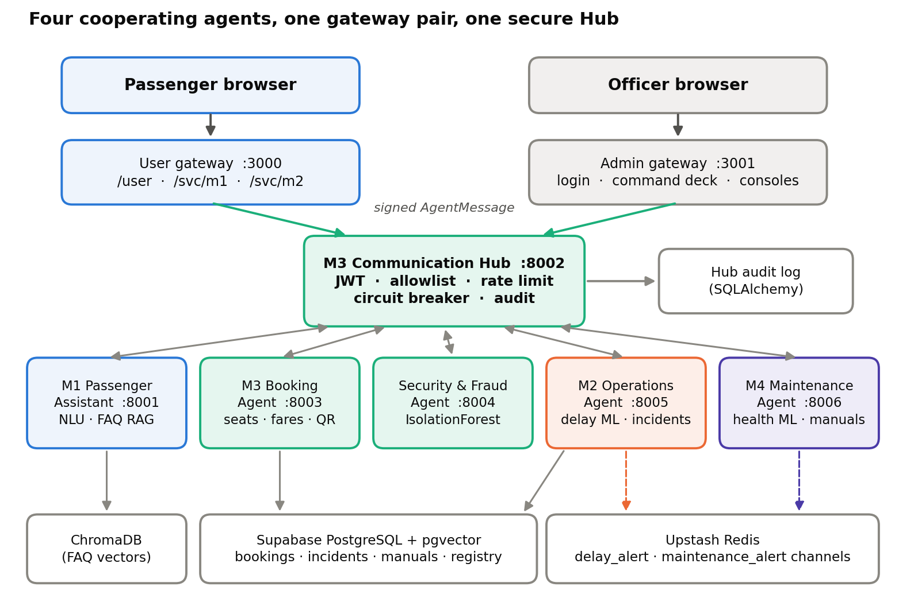
Figure 1. RailSense AI architecture: two gateway sides, the M3 Communication Hub, four agents and the data layer

Four properties shape the design:
- Hub-mediated agent traffic. A sender creates an AgentMessage signed with a JWT; the Hub validates the schema, sender and audience, checks the interaction allowlist, audits the event and forwards it to the receiver.
- One train registry. The Supabase trains table is canonical for every agent.
- Deterministic money and seats. Availability and fares are computed by the booking service; cancellations and flagged bookings are reviewed by people.
- One clock. Every “today”, live position and map cut-off uses Asia/Colombo time, so answers agree across agents.

3.2 Services and ports
Browsers use only two ports – 3000 for passengers and 3001 for officers. Every agent runs on an internal port chosen at start-up; pages reach agents through the gateway (/svc/m1, /svc/m2, /svc/m4), so no page hard-codes a port.
Table 3. Services, default ports and entry points.
Service | Port | Entry point | Purpose
Gateway – user side | 3000 | frontend/serve.py | Passenger portal, booking desk, chat app, Choo assistant, verified-incident map
Gateway – admin side | 3001 | frontend/serve.py | Officer login, command deck, M2 Control Room and Admin Console, fraud and cancellation queues, Hub monitor, M4 maintenance
M1 Passenger Assistant | 8001 | M1-passenger_assistant/backend/main.py | Multilingual chat, NLU, FAQ RAG, dispatch
M3 Communication Hub | 8002 | agent-hub/main.py | JWT verification, allowlisted routing, audit, rate limiting, circuit breakers
M3 Booking Agent | 8003 | booking-agent/main.py | Schedules, seat holds, fares, bookings, cancellations, waiting lists
Security and Fraud Agent | 8004 | security-agent/main.py | IsolationForest risk scoring and review workflow
M2 Operations Agent | 8005 | M2-operations-agent/main.py | Delay prediction, live journeys, incident NLP and RAG, Control Room, Admin Console
M4 Maintenance Agent | 8006 | M4-maintenance-agent/main.py | Asset health Prediction, maintenance flags, reports, manual RAG, engineer assistant
A single cross-platform launcher, start.py, checks the setup, resolves free ports, builds the M1 chat app when its sources change, starts all six agents and both gateway sides in one terminal, waits until each reports healthy and prints the two URLs. A docker-compose.yml describes the same services as containers for server deployment.

3.3 Unified gateway
The gateway (frontend/serve.py) serves both public sides and keeps sensitive material on the server:
- Serves the passenger pages (/user, /user/booking, /user/confirmation, /user/chat) and the officer pages (/login, /admin, /admin/operations/*, /admin/bookings, /admin/maintenance, /admin/security, /admin/hub, /admin/cancellations), and forwards a page opened on the wrong side to the right one.
- Publishes /railsense-config.js so pages learn the live ports without hard-coding them.
- Passes browser calls through to M1, M2 and M4 (/svc/{agent}/{path}).
- Signs booking and cancellation messages server-side with the shared JWT secret, wraps them in an AgentMessage and posts them to the Hub. Database credentials and the inter-agent secret are never sent to browsers.

3.4 Data layer
Table 4. Data stores and what they hold.
Store | Used for
Supabase PostgreSQL | Booking tables (trains, train_schedules, bookings, passengers, fraud_reviews, seat_holds, waiting_list_entries, cancellation_requests, idempotency_records, audit_logs), M2 operational history, incident reports, officers and audit events, M1 chat sessions (chat_sessions, chat_messages, chat_summaries, passenger_accounts, feedback), M4 asset history and maintenance events.
pgvector (384-dimension, all-MiniLM-L6-v2) | M2 incident embeddings (match_incidents), M3 cancellation-policy embeddings, M4 manual embeddings (match_manual_sections).
ChromaDB | M1 FAQ collection (passenger_faq): fares, policies and schedules.
Upstash Redis | Alert channels: M2 publishes delay_alert, M4 publishes maintenance_alert.
Hub audit log | Every routed or rejected message, with correlation id and duration.
Local fallbacks | CSV/JSONL data and TF-IDF retrieval let M2 and M4 keep working if the cloud store is unreachable.

3.5 The four agents

3.5.1 M1 – Passenger Assistant (Thisarani Kawya)
M1 is the passenger-facing conversation layer. It owns the chat window and its own FAQ knowledge; for operational questions it hands the work to the agent that owns that topic and presents the reply.
- Language: Unicode-script detection for Sinhala and Tamil with langdetect for other text; replies come back in the passenger’s language using trilingual templates.
- NLU: keyword intent classification over schedule, fare, delay, train status, booking, cancellation, policy and complaint intents, plus entity extraction for stations, train names and numbers, dates, times, class and passenger count.
- FAQ RAG: three FAQ documents (fares, policies, schedules) split by section, embedded with all-MiniLM-L6-v2 into ChromaDB, top-3 retrieval with an intent-based source filter and citations.
- LLM: OpenRouter through the OpenAI SDK with an ordered chain of free models; without a key, the retrieved FAQ text is returned directly.
- Interfaces: a React chat app (/user/chat) and the Choo floating assistant on the passenger portal.

3.5.2 M2 – Operations and Delay Prediction (Pasindi Alawatta)
M2 is the operational brain: it predicts delays, tracks live journeys, triages incidents and gives officers a Control Room and an Admin Console.
Table 5. M2 components.
Component | What it does
Delay prediction | Looks up exact historical matches first (high confidence); otherwise a GradientBoostingRegressor predicts delay minutes (medium confidence, or low for unusual values or thin samples); explains the result with retrieved similar incidents; publishes a delay_alert when the predicted delay is 5 minutes or more.
Live tracker | Station-by-station timetable on the Asia/Colombo clock, correct overnight handling, and verified map incidents that delay every later stop, each sized by retrieving similar past incidents.
Passenger answers | /passenger/ask (popup) and /passenger/query (free text): intent rules with a TF-IDF fallback for typos, station, train and time entity extraction, journey search (“trains to X after 19:15”), station ETAs, incident and network overviews.
Incident pipeline | Sanitised report → classification and summarisation → pending → administrator approve or reject → verified public map (current day only).
Operations Assistant | Gemini function calling over seven role-filtered data tools, a number guard, fixed refusal messages, per-user history and technique badges (LLM, NLP, IR, RAG, ML, Explainable AI, Security, Protocol, Responsible AI).
Control Room and Admin Console | KPIs, heatmaps, model metrics and feature importances, incident management, officer RBAC (bcrypt, signed tokens, last-administrator lock-out), retraining with archived versions and rollback, audit explorer, live health.
Corpus refresh | Keeps every historical record, moves dates up to yesterday, adds recent records with deterministic ids, upserts to Supabase and indexes new notes for retrieval; safe to re-run.

3.5.3 M3 – Communication Hub, Booking and Security (Navoda Dasun)
- Hub: schema validation, JWT authentication, interaction authorisation, registry lookup, de-duplication, rate limiting, circuit breakers, SQLAlchemy audit, a live monitor (/api/hub/dashboard, /api/hub/timeline) and a start-up handshake (POST /register). Section 4 gives the full pipeline.
- Booking: schedules, first- and second-class availability, deterministic fares, seat holds, idempotent bookings, QR e-tickets with verification, cancellations with NLP-explained human review, waiting lists, maintenance-aware booking blocks, and an administrator booking copilot.
- Security and Fraud agent: behavioural features (booking velocity, cancellation ratio, duplicate seats, route switching, timing) feed an IsolationForest that produces a risk level (LOW, MEDIUM, HIGH) and an action (ALLOW, REVIEW, REJECT); reviewers label outcomes in the fraud queue, and an advisory summary is written for the officer.

3.5.4 M4 – Maintenance and Asset Intelligence (Dilranga M.M.P.M)
- Asset health: gradient boosting models trained per asset type on service age, fault history and telemetry, with permutation feature importance exposing the drivers behind each score; technician notes are parsed into structured facts, and maintenance reports and a fleet summary give engineers a depot-level view.
- Manual RAG: eight equipment manuals retrieved through pgvector or a local TF-IDF fallback, filtered by a relevance threshold and re-ranked before use.
- Engineer assistant: intent classification and train NER (name, typo, M4 id, service number, loco or asset id) resolve the subject, then live flags, latest inspections and open reports are gathered alongside the retrieved manual sections; the Groq LLM composes the answer, which is rejected outright if it contains any number or identifier absent from that evidence..
- Train flags: engineers flag or clear a train; the state syncs to the shared registry so booking respects it; maintenance_alert events are published.

3.6 End-to-end scenarios

Scenario A – “Is the train delayed?”
- The passenger types the question in the chat; the gateway forwards it to M1.
- M1 detects the language, classifies the intent as a delay or train-status question and extracts the train, station and time.
- For operations intents M1 calls M2 (/passenger/query); the same request can also travel as a signed delay_check message through the Hub to M2’s /hub/message.
- M2 parses the query, reads the live board and journey, applies any verified incidents on the path and returns a grounded answer with its source.
- M1 presents the reply in the passenger’s language.

Scenario B – Booking a ticket with fraud screening
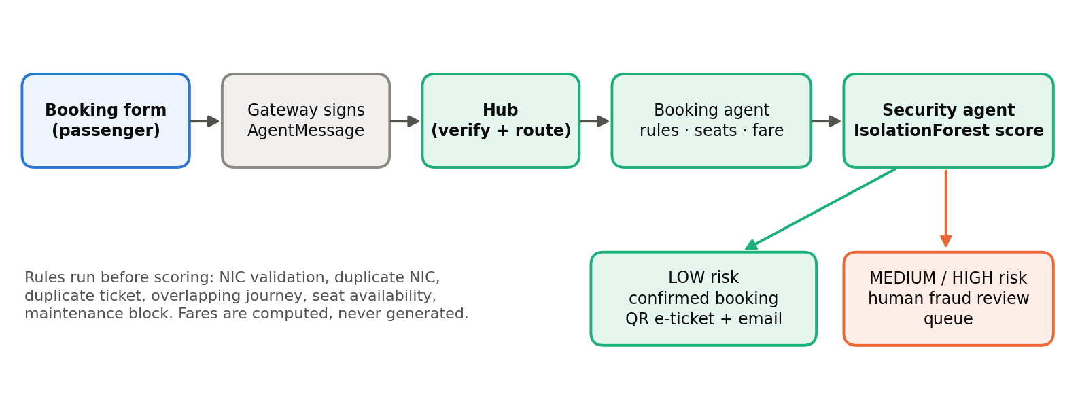
Figure 2. Booking flow from the passenger form to a confirmed ticket or a human fraud review.
- The gateway signs a booking_request AgentMessage and posts it to the Hub, which authenticates and routes it to the Booking agent.
- Booking validates NICs, checks duplicate NIC, duplicate ticket and overlapping journeys, confirms seat availability and computes the fare deterministically.
- Booking asks the Security agent for a risk score through the Hub (fraud_score_request); the IsolationForest returns LOW, MEDIUM or HIGH.
- LOW risk produces a confirmed booking with a QR e-ticket and confirmation email. MEDIUM or HIGH creates a fraud review for a human, and the passenger sees a pending-review status.

Scenario C – Maintenance flag propagates to booking and passenger status

The asset-health model scores a bogie RED; the engineer assistant surfaces it in the fleet summary alongside the latest inspection and any open reports.

The engineer reviews the record and flags the train through M4, supplying a reason and an expected clearance time.

M4 syncs the state to the shared train registry as OUT_OF_SERVICE and publishes a maintenance_alert through the Hub.

The Booking agent reads the registry and rejects new bookings on that train with TRAIN_UNDER_MAINTENANCE.

M1 reads the flag directly from M4 (/api/train-status/{train_id}), so a passenger asking about that service is told it is under maintenance, with the reason and expected return to service, rather than receiving M2's statistical prediction.

When the engineer clears the flag, the registry reverts, bookings reopen and M1 falls back to M2 for the delay answer.
Scenario D – Incident report to the public map
- A report is submitted to M2. Validation limits its length, rejects control characters and rejects any markup.
- M2 classifies the incident (for example signal fault, weather or mechanical) and produces an extractive summary; the record is stored as pending and indexed for retrieval.
- An administrator approves or rejects it; approval requires the incident-review permission.
- The map feed publishes only verified incidents from the current day, through a fixed allowlist of public fields, to the passenger, admin and Control Room maps within seconds.

4. Agent Communication Protocol

4.1 Protocol choice
The assignment allows MCP, A2A, API-based protocols and others. RailSense AI uses an API-based protocol: HTTP with structured JSON, defined by a single versioned AgentMessage envelope (schema version 1.1) and routed through the M3 Communication Hub. The envelope is deliberately MCP-inspired – a typed, self-describing message with an explicit intent – but it is the project’s own application-level contract.
Reasons for the choice:
- Interoperability: every agent is an independently deployable FastAPI service.
- Clear contracts: the same Pydantic model validates messages at the Hub and at the receiver.
- Security: authentication, authorisation and rate limits are enforced in one place before any agent sees a message.
- Traceability: every message carries an id and correlation id and is written to the audit log.
- Demonstrability: one message can be shown leaving the sender, passing the Hub and returning a response.

4.2 Message envelope
Table 6. Fields of the Agent Message envelope.
Field | Type | Meaning
message_id | string | Unique id of this message
sender_agent | string | Name of the sending agent
receiver_agent | string | Name of the receiving agent
intent | enumeration | What the message asks for (see Section 4.3)
payload | object | Intent-specific content
auth_token | string | Bearer JWT issued for the sender
timestamp | datetime | Time the message was created
correlation_id | string, optional | Ties a response and follow-ups to one conversation; defaults to message_id
parent_message_id | string, optional | The message this one answer
schema_version | string | Envelope version, currently 1.1
hop_count | integer ≥ 0 | Incremented on forwarding; used as a loop guard

4.3 Intents and the interaction allowlist
The Hub denies every interaction that is not explicitly allowed. The allowlist names the sender, the receiver and the intent.
Table 7. Message intents and allowed interactions.
Sender → Receiver | Allowed intents | Purpose
Passenger → Booking | booking_request, cancel_booking | Book or cancel a ticket
Booking → Security | fraud_score_request | Risk-score a booking
Passenger → Operations | delay_check | Ask about delay and status
Operations → Passenger | delay_check_response, delay_alert | Return the answer; announce a delay
Operations → Maintenance | issue_report | Share an equipment-related issue
Maintenance → Operations | incident_report | Share a maintenance-related incident
Passenger → Maintenance | issue_report, train_status_query | Report a fault; ask about train availability
Booking → Passenger, Security → Booking, Operations → Booking | ack | Acknowledge or confirm

4.4 The Hub pipeline
Every message passes nine steps in order. A failure at any step returns a structured error and is audited.
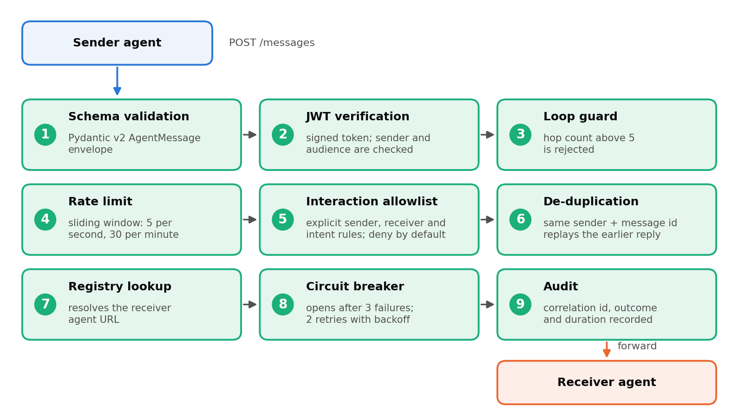
Figure 3. The nine-step Hub pipeline applied to every AgentMessage.
- JWT verification: HS256 with the shared secret, a pinned algorithm list, a required expiry, the token subject matched to sender_agent, and the audience checked against the receiver.
- Loop guard: messages with a hop count above 5 are rejected.
- Rate limit: a thread-safe sliding window per sender (defaults: 5 per second and 30 per minute, configurable).
- De-duplication: a cache keyed by sender and message id replays the earlier response instead of processing a repeat.
- Circuit breaker: a per-receiver breaker opens after 3 failures and recovers after 10 seconds; transient 503/504 responses are retried twice with exponential backoff.
- Audit: the outcome, correlation id and duration are written to the audit log for every message.

4.5 Registration and delegation
At start-up M2 and M4 announce themselves to the Hub with POST /register, sending their agent name, callback URL and capabilities. The Hub confirms the registration against its registry and reports the routes available to that agent. The endpoint is read-only, so a caller can never redirect routing. For delegated calls the Hub can mint a short-lived (300-second) delegation token whose audience is the receiver.

4.6 Event notifications
Besides request and response, agents publish events. M2 publishes a delay_alert (route, train, predicted delay, threshold, timestamp) whenever a prediction reaches 5 minutes; M4 publishes a maintenance_alert when maintenance state changes. Both are sent to Upstash Redis channels through its REST API and are also recorded as operational events shown on the dashboards. Events flow without any passenger chat being open, which shows the agents cooperating autonomously.

4.7 Example message
A booking request as built by the gateway (token redacted; station and train values are illustrative):
{
"message_id": "MSG-WEB-1a2b3c4d",
"sender_agent": "passenger-agent",
"receiver_agent": "booking-agent",
"intent": "booking_request",
"auth_token": "Bearer <JWT: sub=passenger-agent, exp=+3600s>",
"timestamp": "2026-09-29T08:15:00+00:00",
"payload": {
"from_station": "Colombo Fort", "to_station": "Kandy",
"travel_date": "2026-09-30", "train_id": "1005",
"seat_class": "second", "passenger_count": 1
}
}

On success the gateway returns the booking reference, route, date, class, fare, status, ticket token and QR image. When the fraud score requires review it returns PENDING_FRAUD_REVIEW with a case reference, risk level and reasons instead.

5. Methodology
The methodology follows one rule across all agents: compute or retrieve first, generate second, verify last. Deterministic logic and trained models produce the facts; language models phrase them; guards reject anything the evidence does not support.

5.1 Large language models
Each agent uses the provider that suits its task, and every LLM path has a deterministic fallback so the system stays useful when a key is missing or a provider is unavailable.
Table 8. LLM providers, models and fallbacks.
Provider | Model(s) | Used by | Without a key
OpenRouter (OpenAI SDK) | google/gemma-4-31b-it:free → google/gemma-4-26b-a4b-it:free → qwen/qwen3.8-27b:free → openrouter/free | FAQ-RAG answer composition, conversation summarization, and converting structured Hub-agent results into natural-language passenger responses | For FAQ-RAG responses, retrieved FAQ text is returned directly when the LLM is unavailable
Google Gemini (function calling) | Configurable GEMINI_MODEL | M2 Operations Assistant | Rule-based routing to the same data tools
Google Gemini (REST) | gemini-flash-lite-latest; gemini-3.5-flash-lite → gemini-3.6-flash | M3 booking copilot and cancellation explanation | Deterministic fallback
Google Gemini | gemini-2.5-flash | Security and Fraud officer summary | Template summary
 | gemini-3.5-flash-lite → gemini-3.5-flash | Alternative LLM provider for M1 response generation | Depends on the configured provider/fallback behaviour
Groq | qwen/qwen3.8-27b | M4 engineer assistant | Template answer
Anthropic Claude (optional) | claude-sonnet-4-6, claude-haiku-4-5 | Optional NLP tasks in M2 and M4 when a key is configured | Rule-based or extractive default

5.2 Prompt design and grounding
Grounding is enforced by prompt design and by code, not by trust in the model:
- M1: the system prompt instructs the model to answer only from the retrieved knowledge-base context and never to invent a fare, schedule time, availability, delay or policy detail.
- M2 number guard: numbers_grounded() collects every number from the tool results and the question; if the answer contains any other number, it is replaced by a grounded template answer (answer_method = template_after_guard).
- M4 evidence guard: every number and every train, asset or ticket identifier in the composed LLM answer must appear in the retrieved manual sections or the live record set; otherwise the answer is discarded and a fixed template reply is returned. The guard applies to the composition step, so values produced upstream by the asset-health path are not covered by it.
- M2 role-aware assistant: restricted topics are routed to a fixed refusal, tool rounds are capped at four with a 25-second timeout, and tools are filtered by the officer’s permissions.
- Security summaries: the prompt states only facts present in the evidence, acknowledges legitimate explanations such as group travel, and forbids asserting that a passenger committed fraud.
Why this matters
Numbers such as delays, fares and seat counts come from models and databases, never from free generation. If the language model ever produced a number that the evidence does not contain, the answer would be replaced before reaching the user.

5.3 Natural language processing
Table 9. NLP components across the agents.
Component | Agent | Method
Language detection | M1 | Unicode script counting for Sinhala/Tamil → romanized-Sinhala lexicon and fuzzy matching → langdetect fallback for other text
Intent classification | M1, M2, M3, M4 | Keyword rules; M1 additionally matches intents against romanized-Sinhala text to support Singlish/romanized input; M2 adds a TF-IDF fallback for types
Named-entity recognition | M1, M2, M3, M4 | Regex, station/train alias tables and fuzzy matching for stations, trains, dates, times, classes, passenger counts, asset and ticket IDs; M1 and M2 resolve origin/destination roles; M1 also has an optional LLM fallback for unresolved station entities
Incident classification | M2 | Rule-based classifier over five incident classes (signal fault, weather, mechanical, staffing, track obstruction); optional LLM zero-shot
Summarisation | M2 | Extractive sentence scoring, at most two sentences; optional LLM
Technician-note extraction | M4 | Rule-based extraction of components, dates and part numbers; optional LLM
NIC normalisation | M3 | Validation of old and new Sri Lankan NIC formats before hashing
Natural-language generation | M1, M2 | Trilingual templates and grounded LLM phrasing

5.4 Information retrieval and RAG
Table 10. Retrieval modules.
Agent | Corpus | Store and embedding | Retrieval details
M1 | 3 FAQ documents (fares, policies, schedules) | ChromaDB; all-MiniLM-L6-v2 | Split by section with title context; top-3 retrieval; intent-based source filter; distance-threshold off-topic gate for English / railway-keyword gate for Sinhala and Tamil; citations
M2 | Historical incident notes | Supabase pgvector (384-d) or local TF-IDF (1–2-grams) | Top-3 (max 5); retrieved incidents cited in the delay explanation and used to size map-incident delays
M3 | 6 cancellation-policy documents | pgvector policy embeddings | Policy sections grounding the cancellation explanation
M4 | 8 equipment manuals | pgvector or local TF-IDF | Top-3 with relevance threshold and re-ranking; manual sections cited
Retrieval also covers live records: M2 searches the live board and verified incidents, and M4 searches live flags, inspections and open reports, so answers combine static knowledge with current state.

5.5 Machine learning

5.5.1 Delay prediction (M2)
The delay model predicts expected delay in minutes from route, station, weather, day type, incident type and scheduled hour. Categorical features are one-hot encoded and the scheduled hour passes through; a GradientBoostingRegressor (300 estimators, depth 3, learning rate 0.05, seed 42) is trained on an 80/20 split. Saved models are archived with a timestamp and metrics file (ten archived versions are kept), and an administrator can retrain or roll back from the Admin Console; a rollback first saves the current model.
At prediction time an exact historical match is used when it exists; otherwise the model is used. Confidence is reported as high, medium or low, and predictions of 5 minutes or more trigger a delay_alert.

5.5.2 Fraud screening (Security and Fraud agent)
An IsolationForest (100 trees, contamination 0.08, seed 42) is fitted on normal booking behaviour and scores ten behavioural features: booking velocity, cancellation ratio, duplicate seats, route switching, timing and related signals. The anomaly score is mapped to a 0–1 risk index: LOW (0.00–0.39) allows the booking, higher bands send it to human review. Deterministic hard rules (duplicate NIC, duplicate ticket, overlapping journey) run before scoring.

5.5.3 Asset health (M4)
A separate HistGradientBoostingRegressor per asset type (diesel engine, bogie, brake system) predicts a health score from service age, fault history and telemetry (400 iterations, learning rate 0.04, depth 5, 80/20 split, seed 42). Trained on approximately 1,440 asset-history records authored for this prototype, since operational telemetry of this kind is not publicly released; the health score label is derived from [state how]. Held-out performance is [R² / MAE per asset type]. Permutation importance (8 repeats) identifies which readings drive each score and supports the explanation shown to engineers

5.6 Datasets
The project uses synthetic datasets generated with fixed random seeds to reflect Sri Lankan routes, stations, weather and day types. This allows reproducible experiments and keeps real passenger data out of development. The generators are part of the repository.
Table 11. Datasets used for training and evaluation.
Dataset | Size | Details
M2 operations history | 3,900 records, 2026-03-01 to 2026-09-27 | 7 routes, 17 stations, 5 weather types, 3 day types, 6 incident types; columns for scheduled and actual time, incident note and delay minutes; refreshed by a re-runnable corpus script
M2 incident notes | 400 evaluation records; 150 retrieval queries | Labelled by incident class for NLP and retrieval evaluation
M4 asset history | 1,440 records | Three asset types with service age, faults and telemetry
M4 technician notes | 118 evaluation records | Extraction accuracy set
Security evaluation set | 600 samples, 12% anomalous | Behavioural booking features, seed 42
Knowledge documents | M1: 3 FAQ documents; M3: 6 policy documents; M4: 8 manuals | Authored for the RAG corpora

5.7 Explainability by design
Every model output is paired with a reason a person can read: delay predictions include confidence, feature-based explanation and cited similar incidents; fraud results include the reasons behind the risk level and an advisory summary; the Operations Assistant shows technique badges computed from what actually ran; and the M4 assistant cites manual sections.

6. Security Implementation
Security is applied in layers: at the browser boundary (gateway), between agents (Hub), at each agent endpoint (validation and permissions), and in the data layer (hashing, masking and audit).
Table 12. Security controls and where they are implemented.
Control | Implementation | Where
Authentication of officers | bcrypt-hashed passwords (12 rounds); signed, expiring tokens (default 8 hours); last-administrator lock-out | M2 admin, gateway login
Role-based access control | Permission matrix per role; require_permission / require_admin on endpoints; role-filtered assistant tools; admin-only incident approval and model management | M2 admin, M2 assistant
Inter-agent authentication | JWT-signed AgentMessage; sender and audience binding; pinned algorithm; required expiry | Hub
Authorisation of interactions | Deny-by-default sender, receiver and intent allowlist | Hub
Replay and abuse protection | De-duplication, per-sender sliding-window rate limits, hop-count loop guard, circuit breakers with retries | Hub
Input sanitisation | Schema validation with length limits, control-character rejection, bleach markup rejection; slowapi rate limits on public endpoints | M2, M4, M1
Booking integrity | Idempotency records, duplicate NIC, ticket and overlap rules, deterministic fares and seats | Booking
Identity protection | NICs normalised, then HMAC-SHA256 hashed and masked in displays | M3
Public data minimisation | Verified-only incident map with a fixed allowlist of public fields | M2
Secrets management | .env files git-ignored; JWT and database secrets server-side only; template .env.example | All
Auditability | Append-only Hub audit log, officer audit log, audit events and per-query assistant history | M2, M3

6.1 Authentication and role-based access control
Officers sign in with a password stored as a bcrypt hash and receive a signed token with an expiry. Each request is checked against a permission matrix: administrators can approve incidents, retrain and roll back models, manage officers and read the audit trail, while operations engineers use the Control Room and prediction tools. Further predefined roles (operations manager, dispatcher, maintenance officer, security officer, analyst and viewer) are available in the matrix. The Operations Assistant enforces the same permissions on its tools, so a user can never obtain through chat what the role does not allow on screen.

6.2 Securing agent-to-agent traffic
Every message carries a JWT whose subject must match the sender and whose audience must match the receiver, so a token issued for one agent cannot be replayed to another. The Hub then applies the allowlist, rate limit, de-duplication, circuit breaker and audit steps described in Section 4. The gateway holds the signing secret on the server and never exposes it to browsers.

6.3 Input sanitisation and abuse prevention
All public request models limit type and length. Incident text must be 5–2000 characters, control characters are rejected, and any markup is rejected by bleach, which blocks script and HTML injection before text reaches classification, storage or a language model. Public endpoints use rate limiting, and the Hub adds its own per-sender limits.

6.4 Data protection
National identity numbers are validated, normalised and stored only as HMAC-SHA256 hashes, which allows duplicate and fraud checks without keeping the raw number; screens show masked values. Assistant answers for administrators pass through a privacy-masking step. The public incident map exposes only verified, same-day incidents through a fixed allowlist of fields.

6.5 Audit and accountability
The Hub records every routed or rejected message with its correlation id, outcome and duration. M2 keeps an officer audit log and audit events, and stores an answer_method for every Operations Assistant answer. Audit views are read-only in the interface.

7. Responsible AI
Responsible AI was treated as a set of concrete, testable features owned by specific modules, not as a statement of intent. The table below summarises the implementation and the sections after it explain the reasoning.
Table 13. Responsible AI principles and their implementation.
Principle | Implementation | Module
Fairness and inclusion | Trilingual detection and replies (Sinhala, Tamil, English) with multilingual and language-consistency tests; fraud summaries must not accuse and acknowledge legitimate patterns such as group travel; a human makes every fraud decision | M1, M3
Explainability | Feature importance for delay and health models; high, medium or low confidence labels; retrieved-incident explanations; fraud reasons and advisory summaries; technique badges | M2, M3, M4
Transparency | Cited sources on answers; answer_method recorded per assistant answer; “estimate, not a live signal” wording on predictions; technique badges show which of LLM, NLP, IR, RAG, ML and Explainable AI ran | M1, M2, M4
Human oversight | Administrator approval of public incident alerts; fraud review queue; cancellation review with NLP explanation | M2, M3
Grounding and safety | Number and identifier guards, template fallbacks, fixed refusal messages, role-filtered tools | M2, M4
Data protection | HMAC-hashed and masked NICs; masked administrator views; allowlisted public fields; server-side secrets | M2, M3
Misuse prevention | Markup and control-character rejection, length limits, rate limits, signed and de-duplicated Hub messages | M2, M3, M4
Accountability | Hub audit log, officer audit log, audit events, assistant query history | M2, M3
Dataset disclosure | Datasets are synthetic, generated with documented seeds and stated openly in this report | M2, M4

7.1 Fairness and inclusion
Passengers should not need English to get accurate railway information. M1 detects Sinhala and Tamil by script, replies in the same language, and is covered by multilingual and language-consistency tests. In the fraud workflow, fairness means avoiding automatic accusations: the Security agent’s summaries state that they are advisory, recognise legitimate explanations such as group travel or travel agents, and leave the decision to a reviewer, whose outcome is recorded as a label.

7.2 Explainability
Users see why, not just what. A delay prediction reports its confidence, the factors that drive it and similar past incidents. A fraud flag lists its reasons. An asset-health score is backed by feature importance, and maintenance answers cite the manual section they came from. The Operations Assistant displays badges naming the techniques that actually ran for that answer.

7.3 Transparency
Predictions are labelled as estimates rather than live signals, answers cite their source, and the assistant records how each answer was produced (LLM tool calling, template after the guard, or rule-based fallback). When the language model cannot be trusted with a detail, the system says so through a fixed template rather than guessing.

7.4 Human oversight
Decisions with consequences for people stay with people. Incidents appear on the public map only after an administrator verifies them; bookings that the fraud model rates MEDIUM or HIGH wait in a review queue; and cancellations are reviewed with an NLP-generated explanation.

7.5 Data protection and privacy
The design minimises personal data: NICs are hashed and masked, administrator chat views are masked, public map data uses a fixed field allowlist, and secrets never reach the browser. Development uses synthetic data, so no real passenger records were needed to build or test the system.

7.6 Dataset disclosure
All training and evaluation datasets are synthetic and generated with fixed seeds (Section 5.6). This is disclosed openly so results are read correctly: they demonstrate that the pipelines work end to end and are reproducible, and a pilot with Sri Lanka Railways data would be the next step for calibrating the models to real conditions.

8. Evaluation

8.1 Approach
Each learned or retrieval component was evaluated on a held-out or purpose-built set, and the results are stored as JSON artifacts next to the code (evaluation/ folders) so they can be regenerated. Regression models use MAE, RMSE and R²; classifiers use accuracy, precision, recall and F1; retrieval uses Precision@. Automated tests cover the services.

8.2 Results summary
Table 14. Evaluation results by component.
Component | Metric | Result | Data
M2 delay model | MAE / RMSE / R² | 2.254 min / 2.837 min / 0.894 | 3,120 train / 780 test
M2 incident classification | Accuracy, macro P / R / F1 | 1.000 each | 400 records, 5 classes
M2 incident retrieval (pgvector) | P@1 / P@3 / P@5 | 1.000 / 1.000 / 0.999 | 150 queries
Security fraud model (IsolationForest) | Accuracy / precision / recall / F1 | 99.17% / 93.51% / 100% / 0.966 | 600 samples, 12% anomalous
M4 asset-health model | Average MAE / average R² | 3.205 / 0.915 | 1,440 records
M4 technician-note NLP | Accuracy | 0.898 (106 of 118) | 118 records
M4 manual retrieval | P@1 / P@3 / P@5 | 1.000 / 1.000 / 1.000 | 10 queries
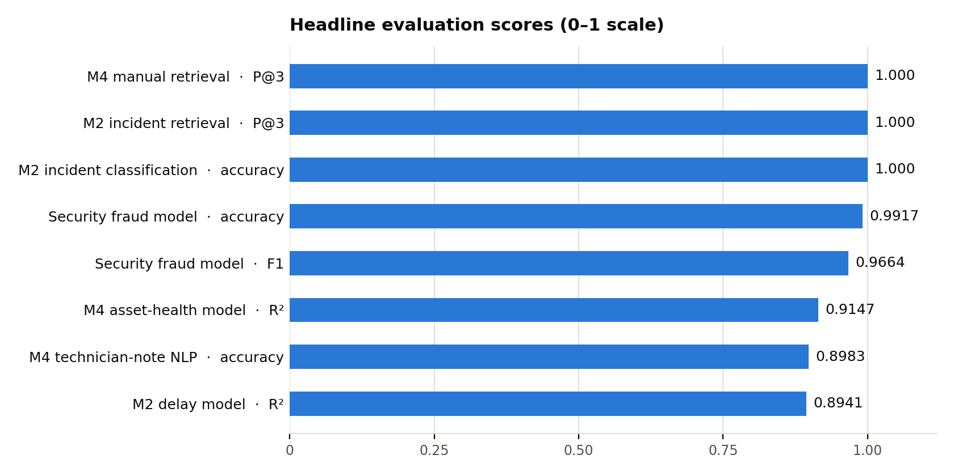
Figure 4. Headline evaluation scores across the agents (0–1 scale).

8.3 Delay prediction (M2)
On 780 held-out records the delay model predicts within about 2.3 minutes on average (MAE 2.254, RMSE 2.837) and explains 89.4% of the variance (R² 0.894). Feature importance shows the model has learned operationally sensible drivers: the presence or absence of an incident dominates, followed by mechanical and staffing incidents and then weather.
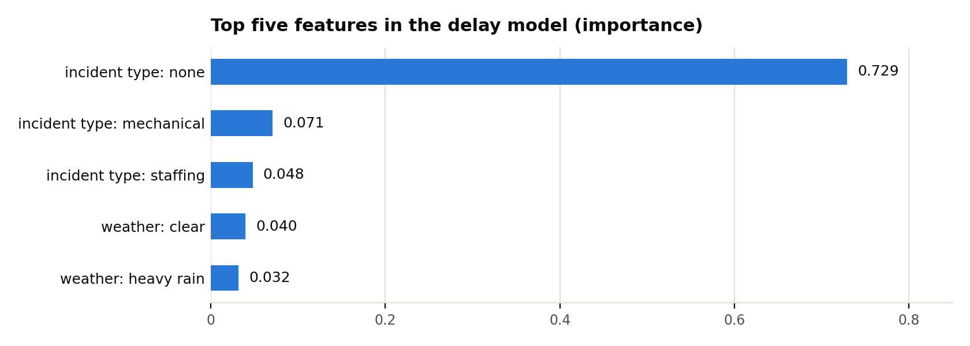
Figure 5. Top five feature importances in the delay model.
The Admin Console exposes the same metrics, feature importances and archived model versions, so an officer can compare a retrained model with its predecessor and roll back with one action.

8.4 NLP and retrieval
- Incident classification (M2): 100% accuracy and macro F1 on 400 records across signal fault, mechanical, staffing, track obstruction and weather classes.
- Incident retrieval (M2): P@1 and P@3 of 1.000 and P@5 of 0.9987 across 150 pgvector queries; a retrieved incident counts as relevant when it shares the query’s incident type.
- Manual retrieval (M4): P@1, P@3 and P@5 of 1.000 on the evaluation queries.
- Technician-note extraction (M4): 89.8% accuracy (106 of 118 notes).

8.5 Fraud screening
On 600 samples with 12% anomalies, the IsolationForest reached 99.17% accuracy with 100% recall (no anomalous booking missed), 93.51% precision and an F1 of 0.966 (72 true positives, 5 false positives). High recall matters here because missed anomalies are costly, and false positives are absorbed by the human review step, which keeps the passenger experience safe. Scoring runs per request in real time.

8.6 Asset health
Per-asset-type models reach an average R² of 0.915 (diesel engine 0.950, bogie 0.911, brake system 0.883) and an average MAE of 3.205 health points, giving engineers a reliable early indicator of assets needing attention.

8.7 Software testing
Table 15. Automated test results.
Suite | Scope | Result
M2 tests | Live tracker, passenger query NLP, prediction, incident pipeline, RBAC | 57 passed
M3 tests | Hub, booking rules, fares, holds, cancellations, fraud integration, admin copilot | 229 passed
M1 tests | Language detection, NLU/intent routing, multilingual & language-consistency behavior, chat ownership & auth, conversation-context summarization, FAQ retrieval (RAG), cross-agent Hub routing, fare/policy consistency with M3 | 309 passed
Integration scripts | Portals, start-up commands, full-system, M1–M2, M3 booking and M4 cross-agent flows | Run against the live stack

8.8 Discussion
The results show that each component performs strongly on its evaluation set and that the pipelines are reproducible from committed artifacts. Because the datasets are synthetic, the perfect scores on incident classification and retrieval reflect well-separated vocabulary in the incident notes; the same evaluation scripts can be re-run on real Sri Lanka Railways incident logs during a pilot to calibrate them. The grounding guards, human review steps and confidence labels are designed so that the system behaves safely even when a model is uncertain.

9. Commercialisation Plan

9.1 Value proposition
RailSense AI is positioned as a business-to-government (B2G) software-as-a-service suite for railway authorities. It replaces four disconnected tools with one connected system and delivers measurable operational value:
- Better passenger communication: live, cited, trilingual answers reduce avoidable enquiries and complaints.
- Earlier warning: delay predictions with explanations and equipment-health scores let staff act before a problem spreads.
- Faster triage: incidents are classified and summarised automatically, then verified by a person before the public sees them.
- Safer ticketing: unusual booking behaviour is flagged with plain-language reasons and reviewed by staff.
- Trust for government buyers: signed messages, role-based access, masked identifiers and full audit trails answer the first question any authority asks about data protection.

9.2 Target users and market
Table 16. Customer segments.
Segment | Who | Why they buy
Primary | Sri Lanka Railways (Department of Railways) and its stations and control rooms | Passenger information, delay visibility, incident handling, maintenance planning and ticketing integrity in one platform
Secondary | Regional rail operators, metro and bus authorities | The same agents apply to any scheduled network; timetables, manuals and policies are loaded as data
Extension | Private and tourist rail operators, freight operators | Passenger assistant and maintenance intelligence with lighter deployments

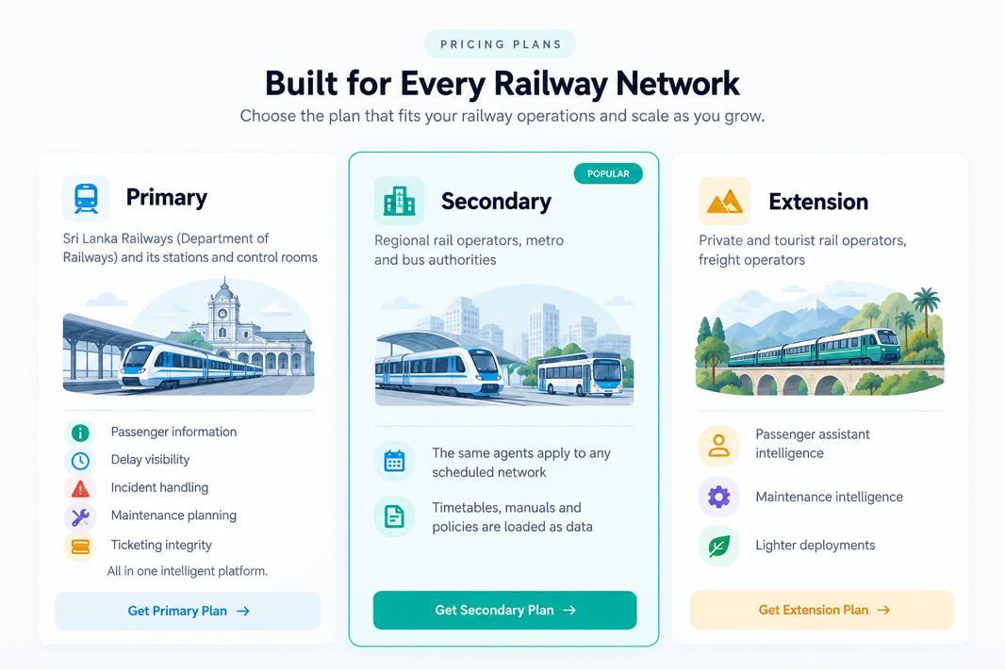

9.3 Product tiers and pricing
Pricing follows the platform’s modular design: each tier switches on more agents. Prices are per station per month, billed annually, and are indicative planning figures to be finalised with the customer after a pilot. USD values are approximate at LKR 300 per USD.
Table 17. Product tiers and indicative pricing.
 | Starter | Operations | Enterprise
Agents included | M1 Passenger Assistant; basic M2 delay prediction and live train board | Starter plus M2 Control Room, Admin Console, incident pipeline and verified map, Operations Assistant; M4 Maintenance agent with manual RAG and train flags | All four agents: adds M3 Booking with QR ticketing, Security and Fraud screening, and the Hub with signed integrations to existing systems
Coverage | One route or region | One region, multiple routes | Network-wide, multiple regions
Officer seats | Up to 5 | Up to 25 | Unlimited, custom roles
Languages | English, Sinhala, Tamil | English, Sinhala, Tamil | English, Sinhala, Tamil, plus custom
Support | Business-hours email | Priority support | Dedicated support with a service-level agreement
Deployment | Cloud SaaS | Cloud SaaS or single server | Cloud, on-premise or hybrid
Indicative price | LKR 40,000 per station per month (≈ USD 135) | LKR 85,000 per station per month (≈ USD 285) | Custom annual contract, from about LKR 9,000,000 per year (≈ USD 30,000)
One-time onboarding | LKR 250,000 per region (≈ USD 830): timetable and knowledge loading, configuration, staff training | LKR 250,000 per region | Included in the custom quote
Add-ons (quoted separately): extra LLM usage packs, additional languages, custom integrations with existing ticketing or timetable systems, and on-site training.
Illustrative example
A regional pilot with 10 stations on the Operations tier would cost LKR 850,000 per month (LKR 10.2 million per year) plus a one-time onboarding fee of LKR 250,000. The Starter tier lets a smaller authority begin with passenger information alone and upgrade tier by tier.

9.4 Cost structure
The architecture keeps running costs predictable. Facts come from trained models, databases and deterministic services; language models only phrase answers, so usage is bounded, and providers can be swapped through configuration.
Table 18. Cost drivers and their current basis.
Cost driver | Used by | Basis
OpenRouter LLM | M1 | Free-tier models during development and pilot; metered in production
Google Gemini API | M2, M3, Security | Flash and Flash-Lite models, low cost per request
Groq API | M4 | Hosted Qwen model, low-latency inference
Supabase (PostgreSQL and pgvector) | All agents | Free tier for pilot; managed paid plan at scale
Upstash Redis | M2, M4 | Serverless alert channels, free tier for pilot
Email (SMTP) | Booking confirmations | Any SMTP provider
Hosting | 6 agents and 2 gateway sides | Single server with start.py or containers via docker-compose.yml

9.5 Deployment options
- Cloud multi-tenant SaaS: stateless services with managed Supabase and Upstash; fastest to start and easiest to update.
- Single server or containers: start.py or docker-compose.yml on the authority’s own infrastructure.
- On-premise for data-residency-sensitive contracts: because every LLM path has a deterministic fallback and retrieval can run on local TF-IDF, the platform can operate with minimal external dependencies.

9.6 Go-to-market
- Pilot (one region or route): deploy the Starter or Operations tier, load real timetables and manuals, and agree success indicators with the authority.
- Measure: record usage and accuracy from the pilot and compare it with the indicators below.
- Expand: move up a tier or add regions using the pilot evidence; negotiate an Enterprise contract for the full suite and integrations.
Table 19. Pilot success indicators.
Indicator | What it shows
Passenger questions answered without staff help | Value of the Passenger Assistant
Time from incident report to verified alert | Value of incident classification, summarisation and review
Delay-prediction error against actual delays | Model accuracy on real operations
Fraud reviews opened and confirmed | Usefulness of screening and reviewer workload
Unplanned maintenance events avoided | Value of asset-health scoring

9.7 Revenue model and sustainability
Revenue is recurring subscription revenue per station, with onboarding fees and add-ons on top. Growth comes from three directions: more stations per customer, movement up the tiers as authorities adopt more agents, and new customers in adjacent transport sectors. Because the agents are separate services with clear interfaces, new capabilities can be sold as additional modules without redesigning the platform.

10. User Interface and Product Showcase
The platform exposes two sides. The passenger side (port 3000) is public; the officer side (port 3001) requires login and shows each officer only what their role permits. Opening an admin page on the passenger side, or the reverse, forwards to the correct side.
Table 20. Portals, pages and audiences.
Page | Path | Fed by | Audience
Passenger portal and live train board | /user | Gateway, M2 | Public
Multilingual chat app | /user/chat | M1 | Public
Choo floating assistant | on /user | M1 → M2 | Public
Booking desk | /user/booking | Booking via Hub | Public
Confirmation and QR verification | /user/confirmation | Booking | Public
Officer login and command deck | /login, /admin | Gateway, M2 admin | Officers
M2 Control Room and Prediction | /admin/operations/control-room, /admin/operations/prediction | M2 | Operations engineer, admin
M2 Admin Console | /admin/operations/admin | M2 admin | Administrator
Bookings and fraud queue | /admin/bookings, /admin/security | Booking, Security | Officers
Cancellation review | /admin/cancellations | Booking | Officers
Hub monitor | /admin/hub | Hub | Officers
Maintenance console and engineer chat | /admin/maintenance | M4 | Engineers

Key screens of the running system:
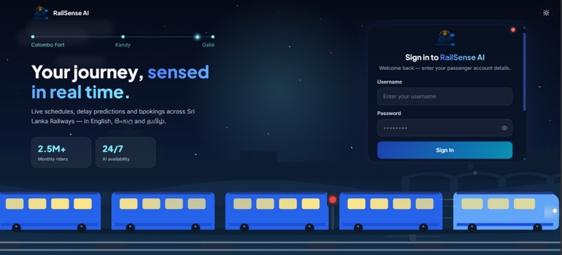
M1 - Passenger Assistant by S M T K Samarathunga
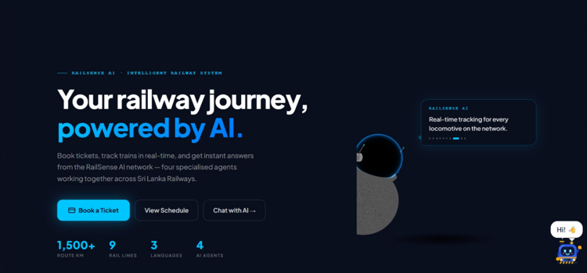
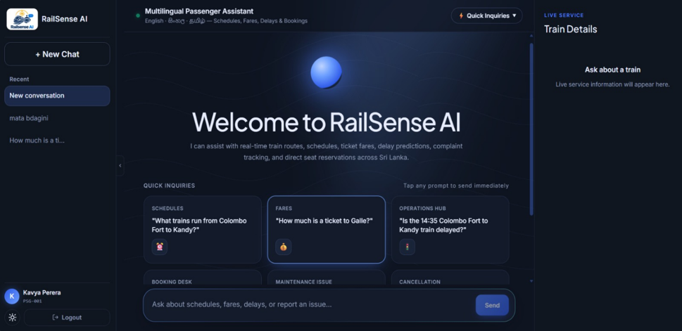
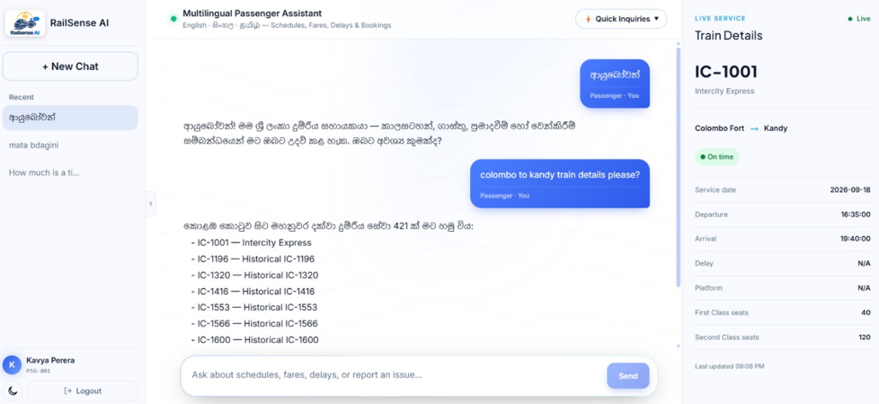

M2 – Operations & Delay Prediction by A K P C N Alawatta
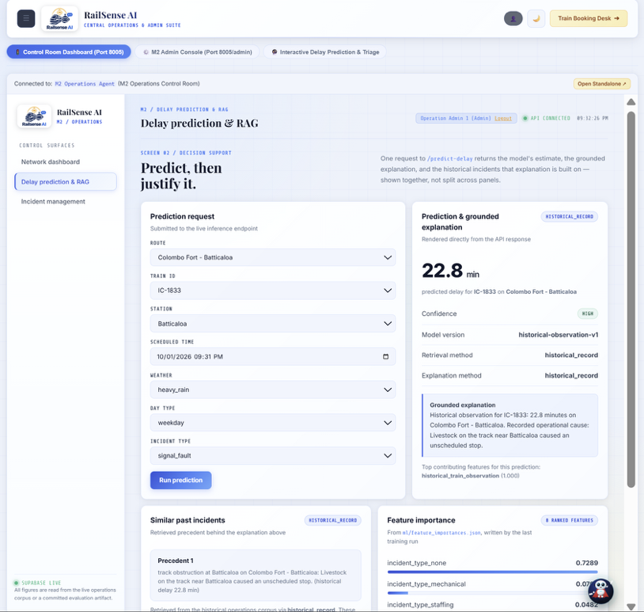
Admin Control room ; Operation Engineers :
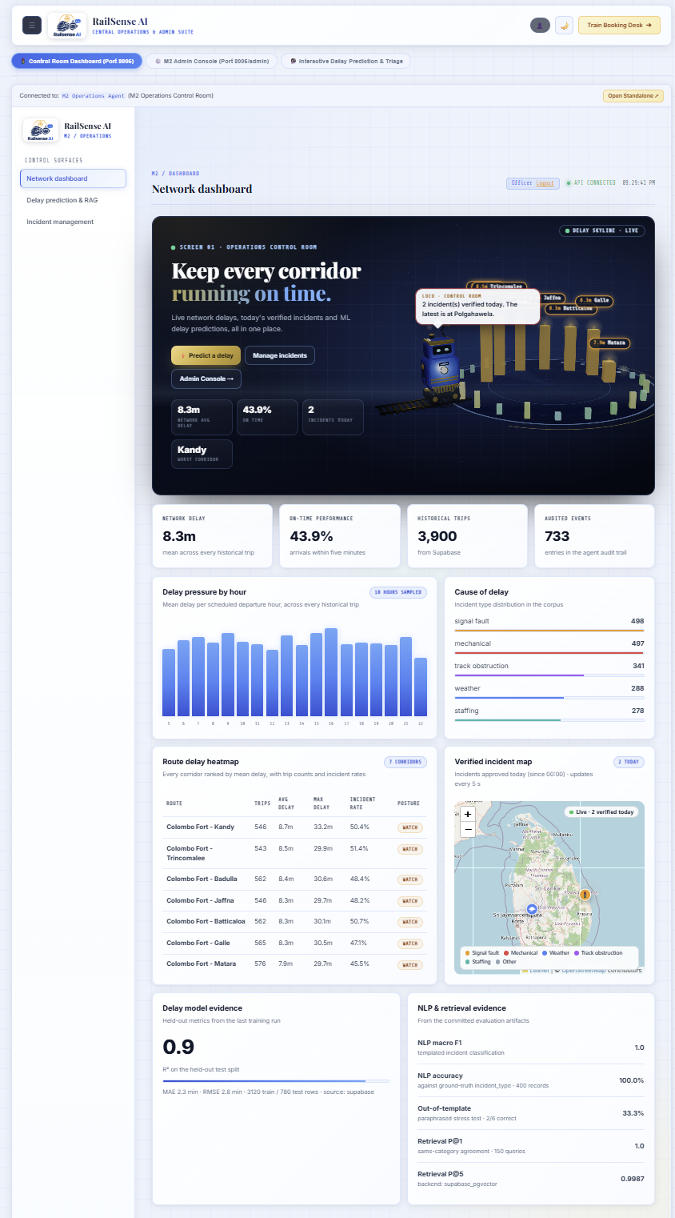

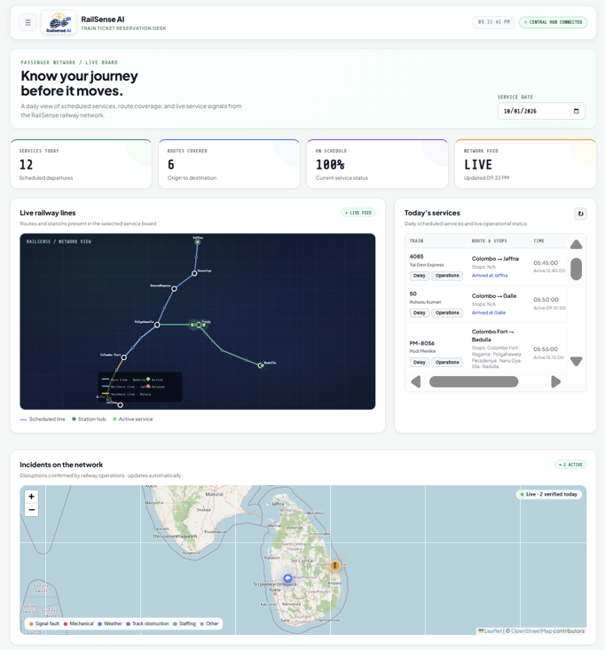
User Side :
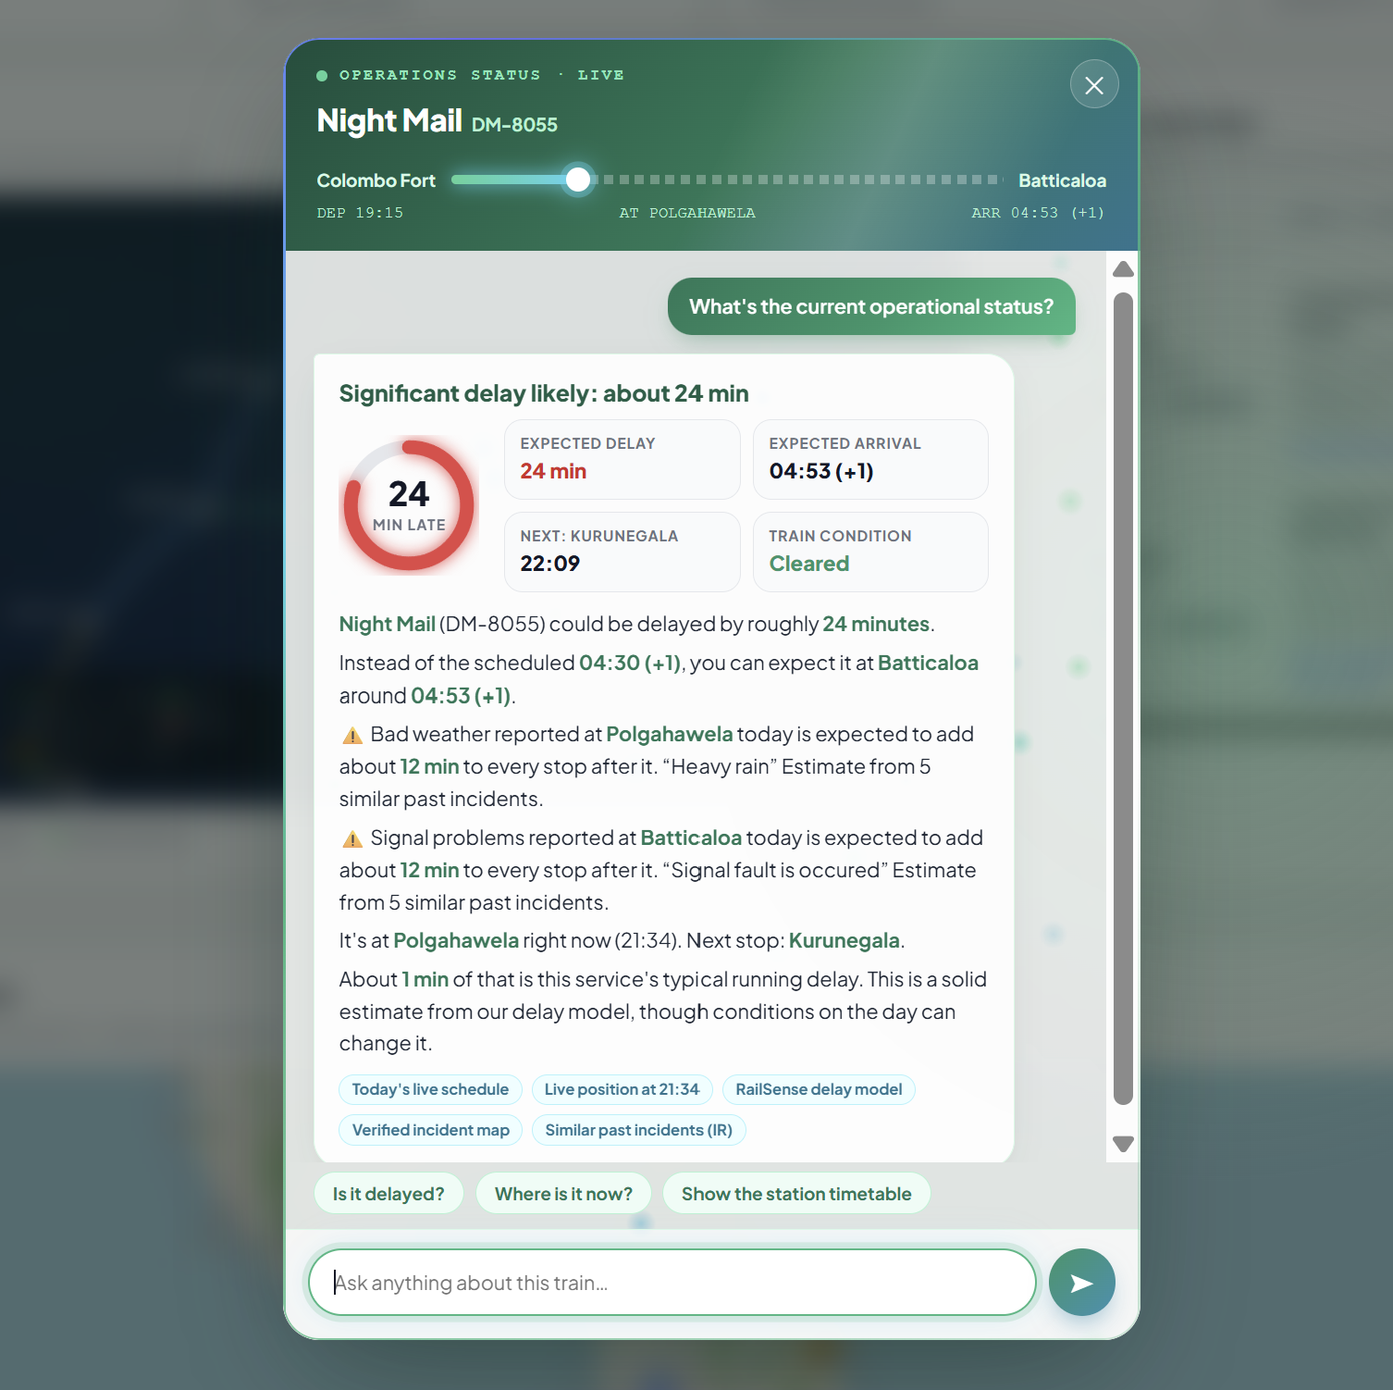

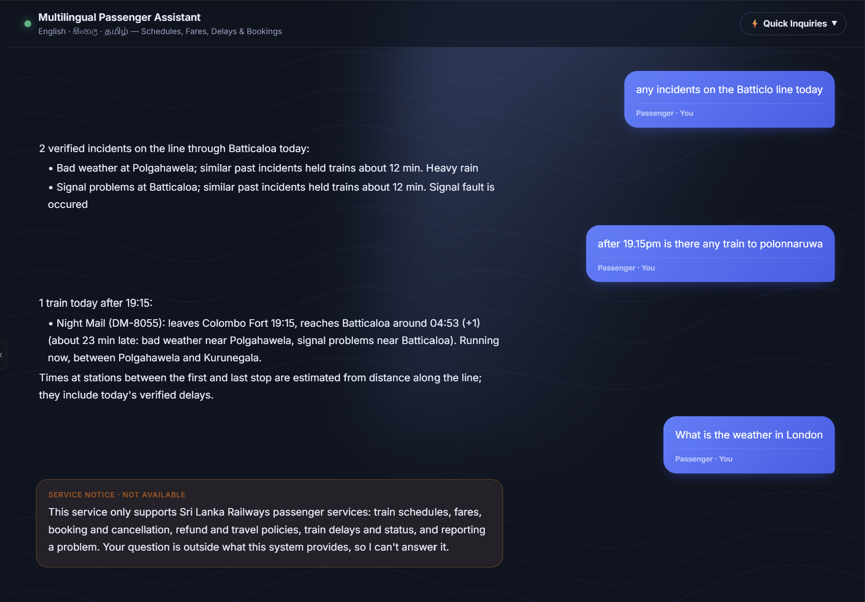
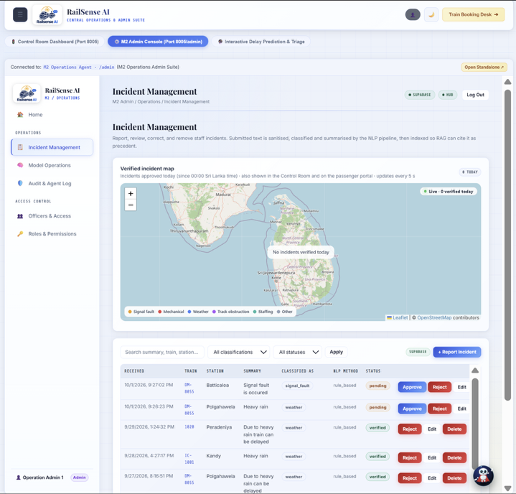
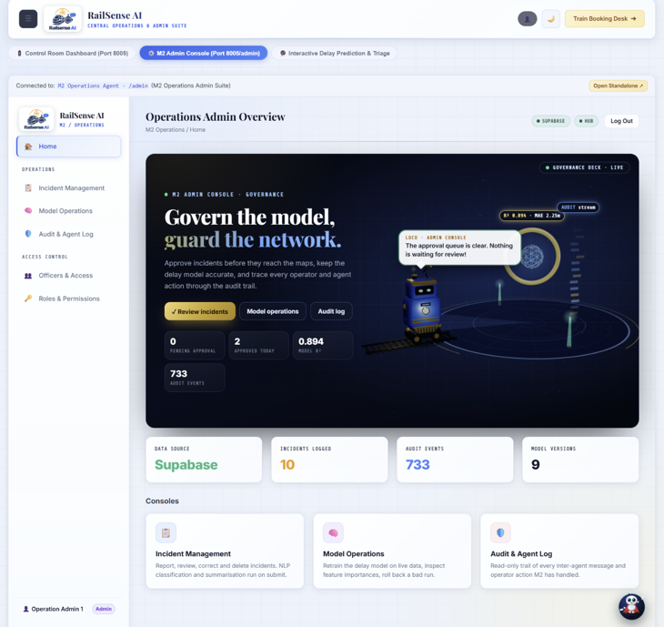
Admin Console Dashboards :
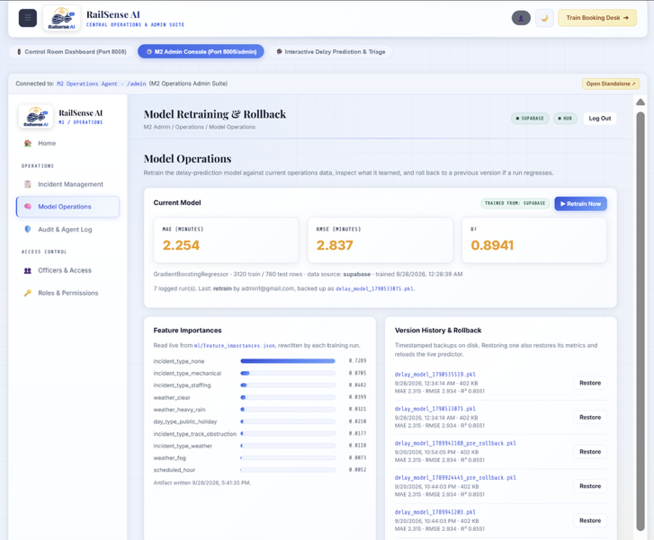

M3 - Communication Hub, Booking and Security by S A N D Aberathna
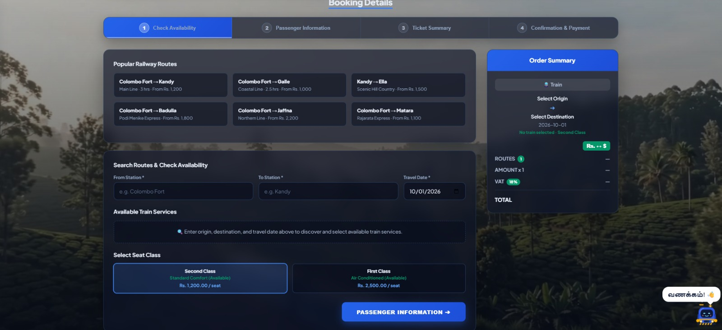
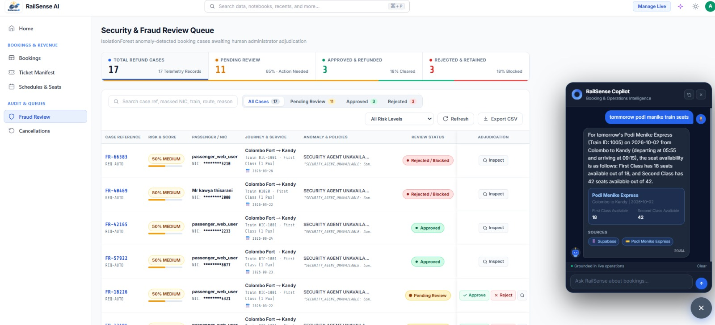
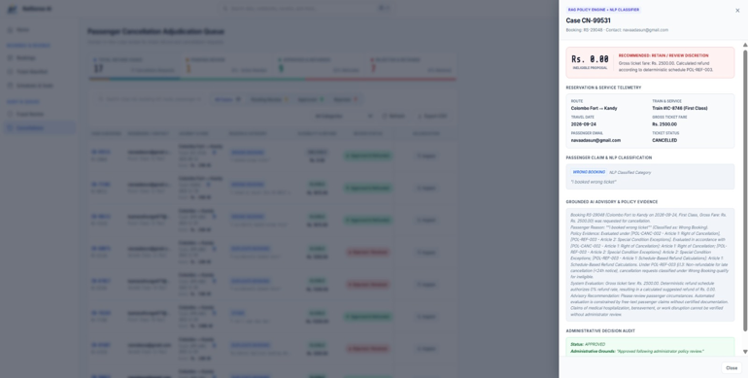
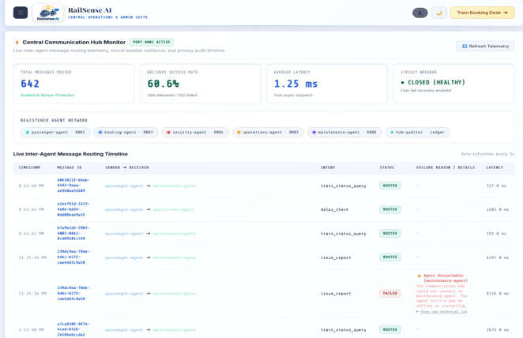
M4 - Maintenance and Asset Intelligence by Dilranga M.M.P.M
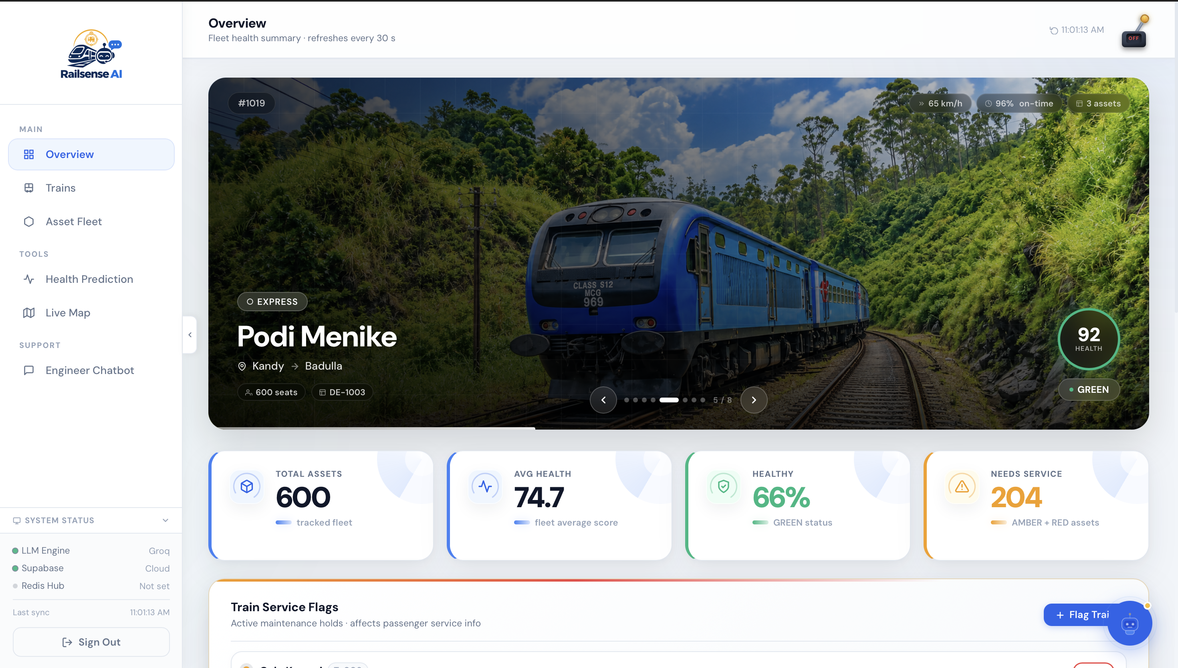
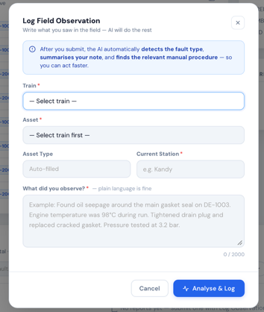
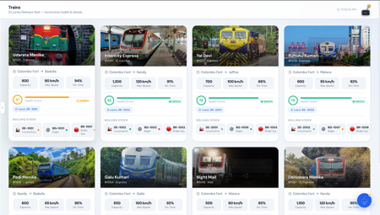
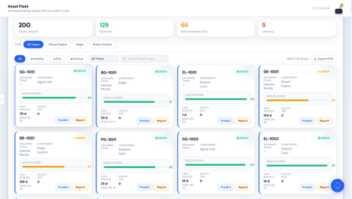
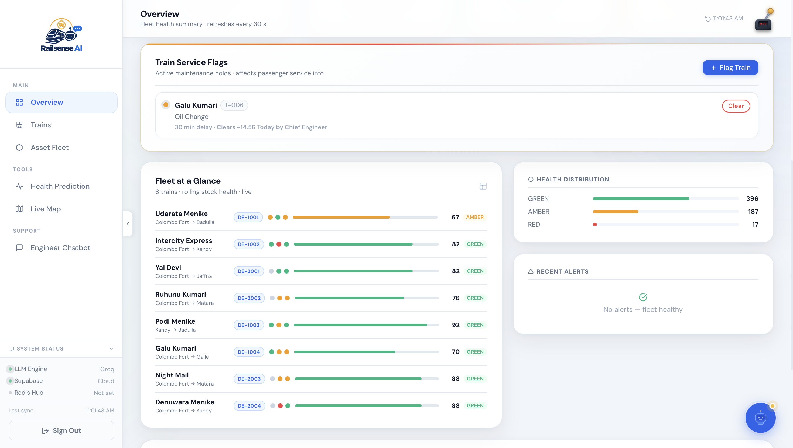
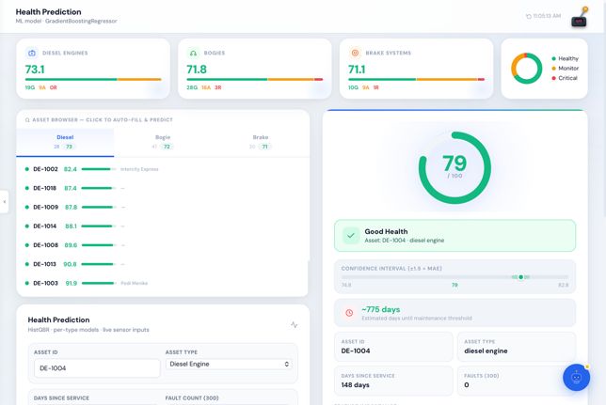
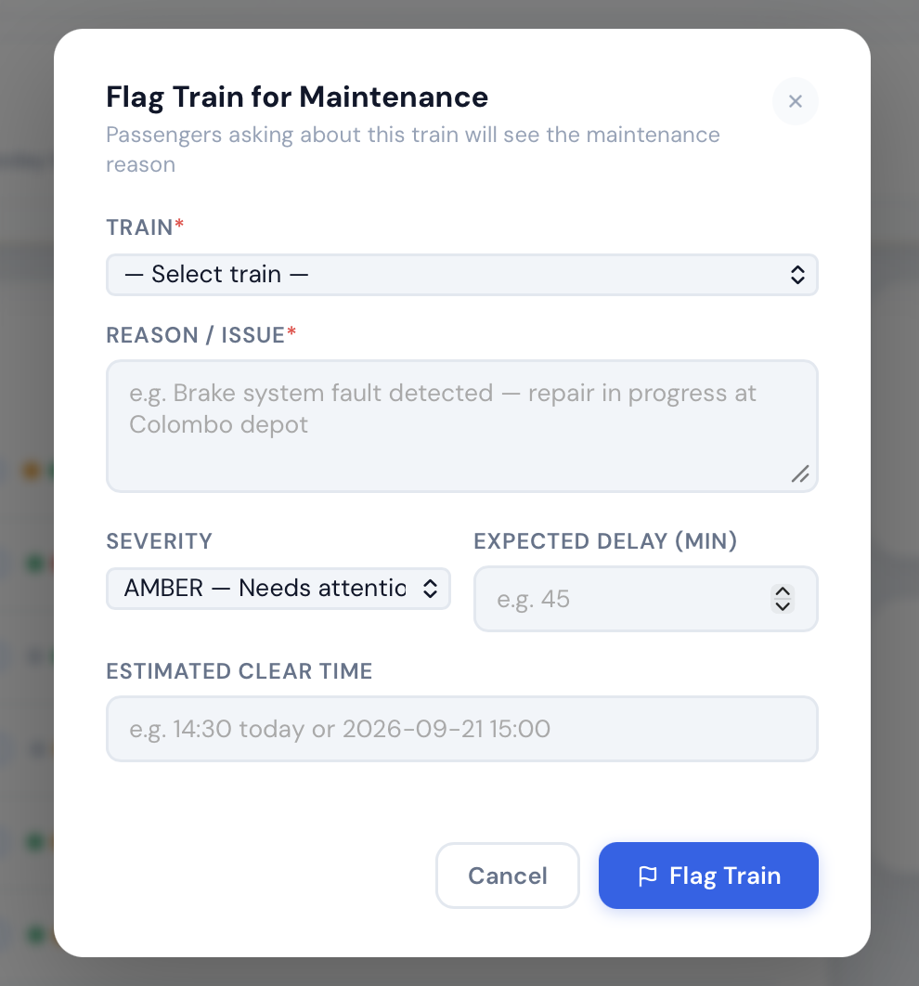
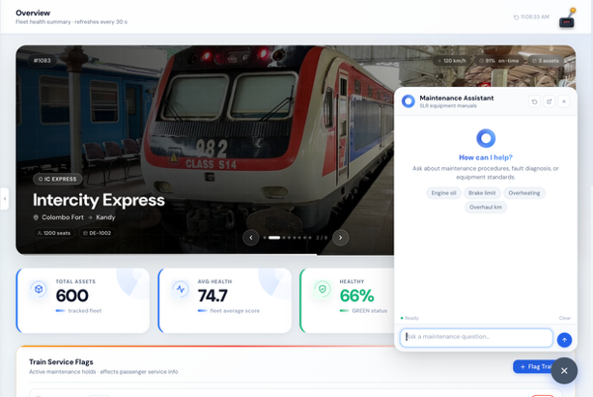
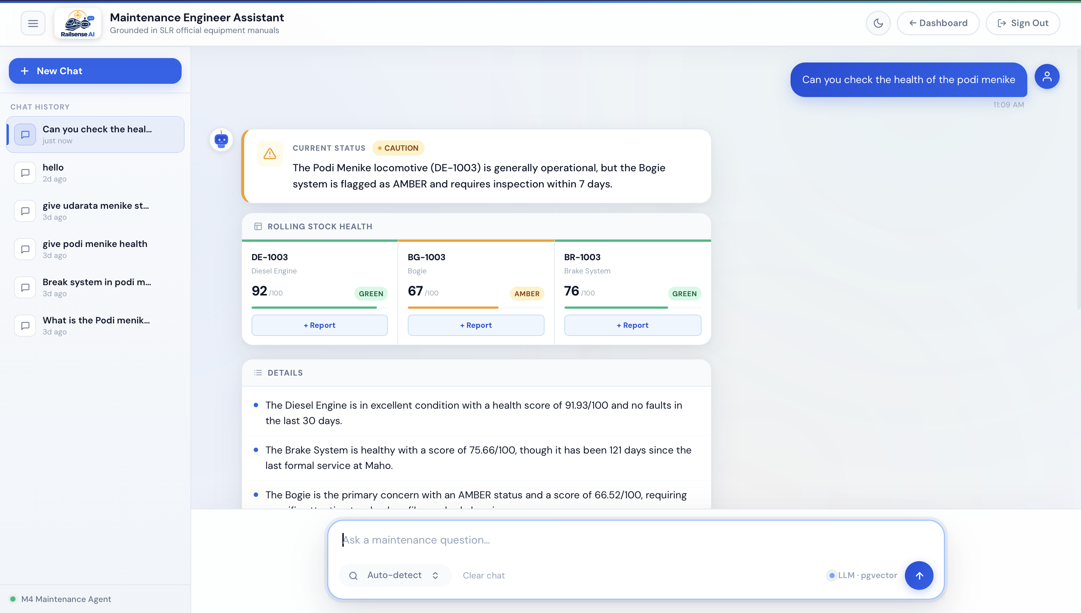

11. Team Contributions
Each member owned one module end to end – design, implementation, evaluation and documentation – and all four contributed to the shared gateway and portals. Individual contributions are visible in the module folders and the Git history.
Table 21. Module ownership and main contributions.
Member | Module | Main contributions
Samarathunga S M TK | M1 Passenger Assistant | Multilingual chat (Sinhala, Tamil, English); language detection, intent classification and entity extraction; FAQ RAG with ChromaDB and citations; OpenRouter LLM integration with fallbacks; React chat app and the Choo assistant; multilingual and language-consistency tests
Alawatta A K PC N (team leader) | M2 Operations and Delay Prediction | Delay-prediction model, evaluation and versioned retraining; live journey tracker; passenger query NLP; incident classification, summarisation and RAG; verified incident map; Operations Assistant with Gemini function calling and number guard; Control Room and Admin Console with RBAC; corpus refresh; team coordination
Aberathna S A N D | M3 Communication Hub, Booking and Security | Secure agent hub with JWT auth, AES-256 encryption, and signed message routing; full booking service with deterministic fares, seat holds, QR e-tickets, waiting lists, and cancellation NLP; IsolationForest fraud detection, input sanitization, and audit logging; booking copilot and admin gateway APIs.
Dilranga M.M.P.M | M4 Maintenance and Asset Intelligence | Per-asset-type health prediction models with permutation-importance evaluation; NER over technician notes into structured facts; manual RAG with relevance thresholding and re-ranking; engineer assistant with the evidence guard rejecting ungrounded numbers and identifiers; train flags synced to the shared registry for booking and passenger status; maintenance_alert publishing and the engineer console.
Shared work: the unified gateway and both portals, the shared train registry and seed data, the launcher and setup checker, the integration test scripts and the repository documentation.

12. Conclusion and Future Work

12.1 Conclusion
RailSense AI shows that a set of specialised agents, connected through one secure Hub and one shared train registry, can serve passengers, operations staff, security reviewers and maintenance engineers better than any single assistant. The system integrates LLMs, NLP, information retrieval, security and a defined communication protocol at real depth: answers are grounded and guarded, decisions with consequences are reviewed by people, predictions are explained, and personal data is minimised, hashed and masked.
Measured results are strong across the board – a delay model with R² 0.894, perfect top-3 retrieval on incidents, a fraud model with 100% recall, an asset-health model with average R² 0.915 – and the automated suites pass (57 tests for M2 and 229 for M3). Together with a tiered commercial plan and flexible deployment options, the platform is ready for a pilot with a railway authority.

12.2 Future work
- Deliver delay_alert and maintenance_alert events to passengers and staff through SMS and mobile push by subscribing to the existing Redis channels.
- Replace distance-based intermediate station times with official per-stop timetables.
- Route passenger maintenance questions from the chat to M4 (the train_status_query interaction is already permitted by the Hub).
- Calibrate and re-evaluate all models on real Sri Lanka Railways data during a pilot, and report language-wise accuracy for Sinhala, Tamil and English.
- Move the Hub rate limiter and de-duplication cache to shared storage for multi-instance scaling.
- Add field-level encryption at rest and mutual TLS between services for production deployments.
- Extend the passenger channel to a mobile app and station kiosks.

References
- Arrieta, A. B., et al. (2020). Explainable Artificial Intelligence (XAI): Concepts, taxonomies, opportunities and challenges toward responsible AI. Information Fusion, 58, 82–115.
- Fielding, R. T. (2000). Architectural Styles and the Design of Network-based Software Architectures (Doctoral dissertation). University of California, Irvine.
- Friedman, J. H. (2001). Greedy function approximation: A gradient boosting machine. Annals of Statistics, 29(5), 1189–1232.
- Jobin, A., Ienca, M., & Vayena, E. (2019). The global landscape of AI ethics guidelines. Nature Machine Intelligence, 1, 389–399.
- Jones, M., Bradley, J., & Sakimura, N. (2015). JSON Web Token (JWT). RFC 7519. IETF.
- Krawczyk, H., Bellare, M., & Canetti, R. (1997). HMAC: Keyed-Hashing for Message Authentication. RFC 2104. IETF.
- Lewis, P., et al. (2020). Retrieval-augmented generation for knowledge-intensive NLP tasks. Advances in Neural Information Processing Systems, 33.
- Liu, F. T., Ting, K. M., & Zhou, Z.-H. (2008). Isolation Forest. Proceedings of the 8th IEEE International Conference on Data Mining, 413–422.
- Pedregosa, F., et al. (2011). Scikit-learn: Machine learning in Python. Journal of Machine Learning Research, 12, 2825–2830.
- Provos, N., & Mazières, D. (1999). A future-adaptable password scheme. Proceedings of the USENIX Annual Technical Conference.
- Reimers, N., & Gurevych, I. (2019). Sentence-BERT: Sentence embeddings using Siamese BERT-networks. Proceedings of EMNLP-IJCNLP, 3982–3992.
- Wang, W., et al. (2020). MiniLM: Deep self-attention distillation for task-agnostic compression of pre-trained transformers. Advances in Neural Information Processing Systems, 33.
- FastAPI documentation, Pydantic documentation, ChromaDB documentation, Supabase and pgvector documentation, Upstash Redis documentation, OpenRouter, Google Gemini API and Groq API documentation (accessed September 2026).
- Model Context Protocol specification (modelcontextprotocol.io), consulted as design inspiration for the typed message envelope.
- Assignment brief: Agentic AI-Based System Development, IT3041 Information Retrieval and Web Analytics, SLIIT.

Appendix A. Running the Platform
Prerequisites: Python 3.10 or later, Node.js 18 or later, and Git. All team members use the same Supabase project.
git clone <repository> && cd RailSence-AI
cp .env.example .env # fill in the shared values
python check_setup.py # shows what this machine is missing
python start.py # starts every service and prints the two URLs

Table 22. Launcher commands.
Command | Effect
python start.py | Checks setup, chooses ports, builds the M1 chat app when needed, starts six agents and both gateway sides, waits until healthy and prints the URLs
python start.py --status | Shows which ports are free, used by RailSense or used by other programs
python start.py --stop | Stops everything this repository started
python start.py --no-build / --rebuild | Skips or forces the M1 chat build
python start.py --no-reload | Runs agents without auto-reload
python check_setup.py | Lists packages per agent, .env key names, Node.js and ports
Open http://localhost:3000/user for passengers and http://localhost:3001/admin for officers.

Configuration keys
The template .env.example lists every key with an explanation; values are never committed. Main keys:
Table 23. Configuration keys (names only).
Key | Needed for
SUPABASE_URL, SUPABASE_SECRET_KEY, DATABASE_URL | Shared database (required)
JWT_SECRET_KEY | Gateway and Hub signed messages (required, identical on every machine)
NIC_HMAC_SECRET | NIC hashing for bookings (required, identical on every machine)
GEMINI_API_KEY | M2 Operations Assistant and M3 language features (optional; fallbacks exist)
OPENROUTER_API_KEY | M1 language-model replies (optional)
UPSTASH_REDIS_URL, UPSTASH_REDIS_TOKEN | Alert channels (optional)
GROQ_API_KEY (M4 .env) | M4 engineer assistant (optional)

Appendix B. Reproducing the Evaluation
# Automated tests
python -m pytest M2-operations-agent/tests -q
python -m pytest "M3-Comunication-Hub&Booking-Agent/tests" -q
python -m pytest M1-passenger_assistant/backend/tests -q
python -m pytest test_m2_rbac.py -q

# Models and retrieval
python security-agent/evaluate_model.py
python M2-operations-agent/ml/train_delay_model.py
python M2-operations-agent/nlp/evaluate_nlp.py
python M2-operations-agent/evaluation/rag/evaluate_retrieval.py
python M4-maintenance-agent/ml/train_health_model.py
python M4-maintenance-agent/nlp/evaluate_nlp.py
python M4-maintenance-agent/evaluation/rag/evaluate_retrieval.py

The committed JSON artifacts under each evaluation/ directory are the source of truth for the results in Section 8; retraining updates them.

Appendix C. Service Interfaces
Table 24. Main routes per service.
Service | Key routes
Gateway | /user…, /admin…, /login, /railsense-config.js, /svc/{m1|m2|m4}/…, POST /api/chat, /api/train-board, /api/booking-options, booking and cancellation routes, /api/admin/*, /api/hub/*
M1 | POST /chat, GET /chat/{session}/history, POST /feedback, /health
Hub | POST /messages, POST /register, /health, /ready, /api/hub/dashboard, /api/hub/timeline
Booking | /internal/messages, booking, seat-hold, cancellation, waiting-list, schedule and ticket-verification routes, /admin/chat
Security | POST /internal/fraud-score, fraud-review routes, /health
M2 | POST /predict-delay, POST /passenger/ask, POST /passenger/query, POST /incident-report, /incidents (approve, reject), /api/incidents/map-feed, /api/dashboard, /api/route-options, /api/trains, /api/stations, /api/ops-agent/ask, /hub/message
M2 admin | POST /admin/api/login, /admin/api/me, officer, model (metrics, versions, retrain, rollback), audit and health routes
M4 | POST /chat, POST /asset-health, POST /maintenance-report, GET /manual-search, POST/DELETE /api/flag-train, /api/train-status/{id}, /api/trains-under-maintenance, /api/dashboard, /hub/message

